Toolbar
Launch Bar
Menu Bar
Title Bar

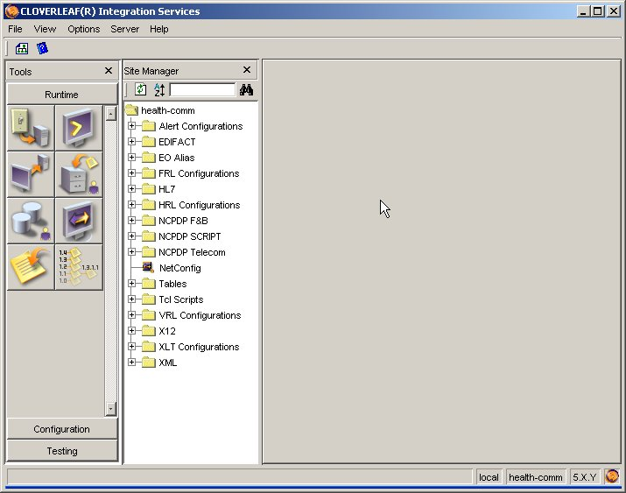

Site Manager Bar
Tool Panel
Status Bar

